Biometric Health Monitoring

**Software Engineering**

**14:332:452**

**Spring 2013**

**Group 12 Members**

Jose Villamor-Delgado

Cody Goodman

Jie Huang

Kyle Raucci

Florian Pranata



**Sequence Diagrams**  
**UC – 2: User Login**  
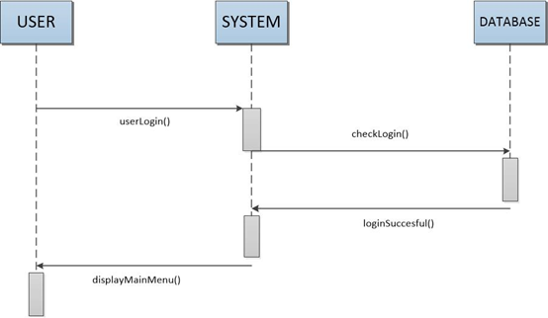  
When users login, it must be checked with the database to make sure it is proper and is in the database. Then after it is successful, the user is returned to a main screen for the logged in user.  
  
**Alternate Case**  
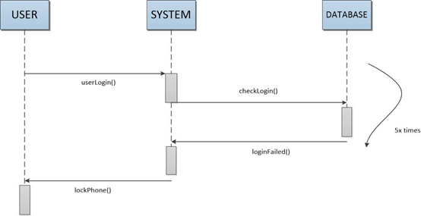  
  
User is asked to log into the system and is then checked with the database for proper login information. The user is allowed 5 times to log in successfully, if not, the screen will return login failure and make user wait a few minutes to login.   
**UC - 3: Client Views Health/Fitness Data**  
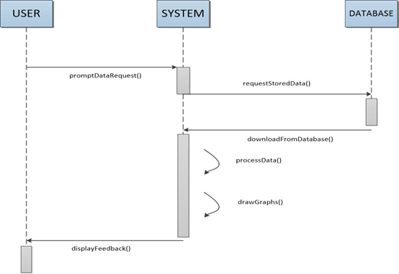  
The user is asked to input data, the data is then stored. When the stored data is needed to the client, the system will ask the database for the information and process the information to what the client wants.  
  
**UC - 4: Client Request for Professional Review**  
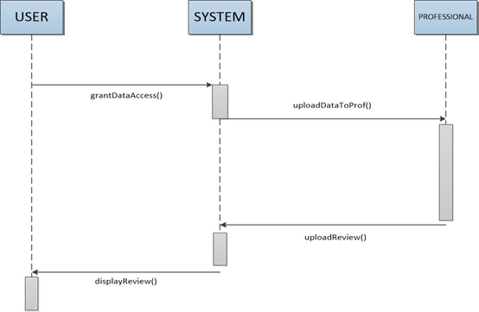  
Clients give permission to their professional advisors. When clients’ advisors ask to get data about the clients, the data is sent to the advisors and allow the advisors to review the data and give some feedback to the clients.  
  
**UC - 7: Client Input/Upload Data**  
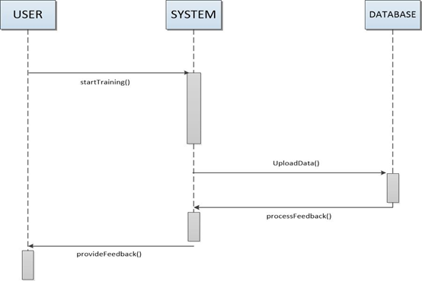  
Clients sends data to the system, the system then uploads the data to database, the database then sends feedback to system then to clients.  
  
**UC – 9: Sharing Client Data/Graphs/Tables to Social Networks**  
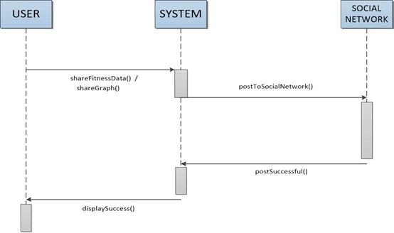  
Clients gives access for the system to share the information about the client’s workout and posts to social medias, when successful, the client will be notified it was successful.  
  
**UC – 12: Generate/Refresh Graphs and Tables**

# https://lh3.googleusercontent.com/nJdposE2dJQMGjyYNZ6-fgm0FFkIl0VcNmxkBc3tIjXJDeoTHra9mdwMictallU1a_u05-_OYGMlSH3IHPmrzws_l9qyXp3g9k_qB4J7TOvgdiEanEnPPNFwkw

Clients request for their data in a graph form, the system then requests database to retrieve the data about the client and process the data and creates a graph. The graph is then displayed to the client side and if the client has new information on their fitness/workout, they can send new/updated information to system and then the system will recreate a new/updated graph and is then displayed to clients.  
  
**Project Management**  
A. Issues and solutions  
 - there was a problem accessing the sql database, still under review  
 - problem accessing website and uploading proper files to make website work, fixed the issue by contacting server manager and used new way to ftp files through adobe dreamwork cs6  
  
B. Project Coordination and Progress Report  
 - currently only the first use case is being implemented but having a few problems accessing and using sql database  
 - will work on user case 3 after fixing problems in user case 2  
  
C. Plan of Work  
February 05 - Research on monitoring devices  
February 06 - Website to be started  
February 12 - Statement of Work & Requirement  
February 16 - Start of App development  
February 18 - Functional Requirements Spec & UI  
February 22 - Full Report # 1  
March 1 - Interaction Diagram  
March 8 - Class Diagram and System Architecture  
March 15 - Full Report # 2  
March 16 - Website launch  
March 23 - App for android/apple device to be finished  
March 24 - Start of testing and debugging  
April 2 - Project Demo # 1  
April 6 - Implement new changes to program (if necessary)  
April 13 - Test and debug new implemented changes of program  
April 27 - Full Report  
May 1 - Project Demo # 2  
May 3 - Finished Product  
  
D. Breakdown of Responsibilities  
 - Jie will work on user case 2 in php and fix uploading and sql database, will also work on creating the interface of website  
 - Kyle and Florain will work on implementing the android version of user case 2 and 3  
 - Cody and Jose will work on user-case 3  
  
**References**  
“Software Engineering Project Report” Marsic. Rutgers University. 16 Feb. 2012. Web. 2. Mar. 2013. <http://www.ece.rutgers.edu/~marsic/Teaching/SE/report2.html>

"Unified Modeling Language" *Wikipedia, The Free Encyclopedia*. Wikimedia Foundation, Inc. 2 Mar. 2013. Web. 2 Mar. 2013. <http://en.wikipedia.org/wiki/Unified_Modeling_Language#Interaction_diagrams>